SSC17-WK-21

Bringing Space to the Classroom Through STEM Education Providing Extreme Low Earth Orbit Missions Using ThinSats

Brenda Dingwall, Joyce Winterton
NASA GSFC Wallops Flight Facility
Wallops Island, VA; 757-824-2969
brenda.j.dingwall@nasa.gov

Dale Nash, Sean Mulligan, Brian Crane
Virginia Commercial Space Flight Authority
4111 Monarch Way #303, Norfolk, VA 23508
; 757-440-4020
brian.crane@vaspace.org

Robert Twiggs, Matt Craft
Twiggs Space Lab, LLC
2340 Old Hickory Lane, Suite 100, Lexington, KY 40515; 859-312-6686
matt.craft@twiggsspacelab.com

Hank Voss, Matt Orvis
NearSpace Launch, Inc.
8702 E. 825 S., Upland, IN 46989; 765-998-8942
mattorvis@nearspacelaunch.com

ABSTRACT
The future of Space Science depends on our ability to attract and engage students into Science, Technology, Engineering and Mathematics (STEM) fields. Authentic, hands-on experience with space applications enhances engagement and learning in the STEM disciplines and can help to attract disinterested students to STEM careers. The Virginia Commercial Space Flight Authority (Virginia Space), Twiggs Space Lab, LLC (TSL), Orbital ATK, NearSpace Launch, Inc. (NSL), and NASA Wallops Flight Facility, have collaboratively developed the ThinSat Program, providing student teams the opportunity to design, develop, test, and monitor their own experimental payload which will be integrated into a pico-satellite and launched from the second stage of Orbital ATK’s Antares Rocket.
The goal of the program is to provide students the opportunity to lead and participate in the development of a spacecraft payload through its life cycle over the course of an academic year. The student experience will be enhanced with classroom visits and videos created by the team to educate the students on satellite manufacturing, environmental testing, satellite integration, spaceport, launch vehicle, range and spacecraft operations. The ThinSat Program will provide a unique and important STEM opportunity for students to develop critical skills in systems engineering and space science that will complement existing programs.

Introduction
Reaching students earlier in their educational development cycle is critical in the development of a workforce for the United States so that it may remain competitive in the global marketplace. Teachers in K-12 education must engage students in STEM curriculum earlier to generate interest, develop skills and provide the educational foundation for students to build upon. The ThinSat Program provides students in middle school, high school and undergraduates the opportunity to learn many valuable STEM skills that can be applied to future learning opportunities and workforce development. This is critical since the aerospace industry is facing a wave of retirements with 18.5% of the workforce eligible for retirement in 2017. (Zillman, 2013) The shortage of scientist and engineers will significantly impact the aerospace and defense industries ability to deliver critical technologies necessary to maintain our technological, economic, and military leadership throughout the world.
Companies within the aerospace and defense industries are attempting to address these issues by establishing closer relationships with programs known for producing STEM talent. Outreach programs to universities and establishing research centers is one solution to the problem. Another solution was the development of the CubeSat Program which emerged from the university community in 1999. “[T]he CubeSat Program was conceptualized as a tool to help teach students about the process involved in developing, launching, and operating a spacecraft. In 1999, California Polytechnic State University’s Multidisciplinary Space Technology Laboratory and Stanford’s Space Systems Development Laboratory began discussing ways to provide students with hands-on experience in the field of spacecraft design.” (Toorian, 2008) Anecdotal information from universities in the United States and around the world, “indicates that hands-on, project-based education is very effective for recruiting, retaining and training engineering students” (Jayaram, 2010). The importance of programs like the CubeSat Program are reflected in national priorities identified by federal agencies.
For years, academia has been unable to fully participate in the space revolution due to high costs, launch availability, and commitment to long term satellite missions. The invention of the CubeSat offered an initial solution to these challenges and sparked many successful CubeSat programs. The success of small satellites in the space sector, has been driven in large part, by technological innovations developed through CubeSat Programs around the world. As of January 8, 2017, a total of 580 nanosats have been launched. All this success has created new challenges for university-based CubeSat programs. Many of these universities are transitioning from an educational program to research and development programs and are developing CubeSats that carry instruments and new technologies for other organizations. As a result, universities are busy writing more proposals to secure funding to insure continuity in their programs. Additionally, the increasing complexity of CubeSats has increased development time from idea to functioning satellite to about three to four years. The problem is that students may not be there for the full development cycle and miss critical aspects of the process. It is important for students to be involved in the development of the spacecraft from conception to operations, and go through all the phases of systems engineering, including mission definition and requirements, system and subsystem requirements and components, designing these systems, testing and verification against requirements. The CubeSat Program has been instrumental in igniting a passion for student’s interest in the fields of science, technology, engineering, and math (STEM). The next breakthrough and step forward in engaging students of all ages and fields of discipline in STEM programming is the ThinSat Program. It is a cost effective, short-term program that provides students with an exciting opportunity to conduct valuable scientific space-based research.
The goals of the ThinSat Program are to address many of the challenges created due to the success of the CubeSat Program and provide new opportunities for students, including: (1) decreasing the spacecraft development cycle time; (2) reducing the complexity and increase reliability; (3) providing regular launch opportunities, thereby increasing space access; (4) engaging students earlier in their education (4th to 12th grade); (5) reducing the burden of paperwork and licensing requirements; (6) mitigating the threat of space debris with short orbital life; (7) reducing the overall cost of spacecraft development and access to space; (8) creating a precursor program to CubeSat programs; and (9) creating a smaller spacecraft platform for valuable space research.
Virginia Commercial Space Flight Authority (Virginia Space) in partnership with Twiggs Space Lab, LLC (TSL), Orbital ATK, NearSpace Launch, Inc. (NSL) and the National Aeronautics and Space Administration (NASA) at Wallops Flight Facility, has developed an educational outreach initiative presented as the ThinSat Program. The purpose of this program is to teach students in middle school and later grades on the iterative engineering design process, systems engineering, data collection methods and analytical processes, and atmospheric and space science. This is achieved by building FlatSats (see figure 1), performing balloon flight operations, designing and building ThinSat payloads to be launched into orbit, and reviewing satellite data for analysis and reporting to the educational and scientific communities. The inaugural flight, as a secondary payload aboard the second stage of the Orbital ATK Antares rocket, is planned for a mission in the fall of 2018. Subsequent flights will occur every 6-12 months. The secondary payload consists of a 12U volume with the capacity to deploy a maximum of 84 ThinSats at an orbit of approximately 200 to 250 kilometers, allowing for a predicted orbital life of 5 days. The altitude range of 100 to 300 kilometers is formally referred to as extreme low earth orbit (ELEO), a section of the atmosphere that has not received much attention due to limited orbit lifetimes. This presents an excellent opportunity for students, who are constrained by the academic schedule, to benefit from a short duration satellite program. Additionally, a nominal Antares launch cadence of two or more per year will provide students the advantage of potentially participating in the ThinSat Program multiple times throughout their academic career.
Prior to the launch of ThinSats as a secondary payload, there will be a structured program to guide teachers and students through the process of developing and testing satellite hardware and data review. The structure contains three phases: Phase 1: Sensor development and low altitude balloon flights; Phase 2: Payload development, high altitude balloon flights and data review; and Phase 3: Flight testing, integration, launch preparations, and final reports. These phases will ensure that students learn the fundamentals of science, engineering and technology necessary to test and launch a satellite into orbit. This is an excellent opportunity to expose students to the space industry and learn the engineering processes. The ThinSat Program will inspire the next generation of space scientists and engineers.

Thinsat Program: Three phases
The ThinSat Program is comprised of three phases that will start fourteen months prior to the relative Antares launch date. The three-phase program culminates with participating schools building a ThinSat payload to be delivered to ELEO. Students have two options when developing their payloads. The first payload option is to utilize a kit of provided sensors that are common to all ThinSats. A second option is for an institution to develop and create a unique, user-defined payload that meets all ThinSat requirements. The phase breakdown is as follows: Phase 1 of the program will introduce the concept of designing a satellite with easy ‘plug and play’ electronic sensor chips and launch of low altitude balloons to gather data up to 10 kilometers; in Phase 2, students will use data obtained from the initial flights to design a payload representative of the flight model to be integrated into a ThinSat engineering model. The engineering model will test the operation and house the payload for a high-altitude balloon flight, which go up to an altitude of 36 kilometers; in Phase 3, data will be analyzed from the prior two balloon flights with the purpose to develop and finalize a flight payload that will be launched on the Antares. Data from each phase will be stored and displayed real-time through a Space Data Dashboard Interface. Students will access this platform through the Virginia Space website (www.vaspace.org). A compilation of graphs and information will form a personalized dashboard interface for participating institutions. The Space Data Dashboard will also allow schools to collaborate, share information, and upload presentations and reports.

Phase 1A
In Phase 1A of the program, students are introduced to sensors, software, electronics, and data collection methods. The students design, construct and test various configurations of a FlatSat. Each participating school will receive ten electronic satellite kits, which include multiple sensors, power supplies, and related software, manufactured by Xinabox Inc. (xinabox). The chips have a user-friendly “plug and play” connection method to form a FlatSat. The small square connectors between the X-Chips make it very easy to connect and no soldering is required. X-chips are preprogrammed to ensure students who are not familiar with coding, still have the ability to build a FlatSat. Those students who are interested in coding have the option to program the X-chips. In both scenarios, students are exposed to the software and the effects of programming in real-world applications. Once programmed, the X-chips will be tested and operationally verified by using the WiFi or USB modules to connect to an online dashboard, where information will be displayed real-time and stored.
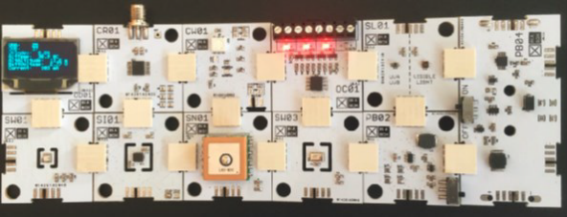
Figure 1: FlatSat/X-Chips

The Xinabox Kits Include:
- Sensors to build Ten (10) FlatSats
  - USB programmer
  - Programmable WiFi Unit
  - OLED Display Chip for sensor data
  - Light sensor including UVA and UVB
  - Weather sensor (temperature, humidity, and altitude)
- Two (2) Balloon Mission Packs with:
  - Long Range transceiver (915 MHz) and monopole antennae
  - Burn Wire Module (burn wire unit to run 4 stages of mission)
  - Battery Pack Power Supply unit (2XAA)
  - GPS sensor
  - Inertial Motion Unit (accelerator, magnetometer, and gyroscope)
  - Light sensor (UVA and UVB)
  - Weather sensor (temperature, humidity, and altitude)
  - Large party balloons and parachutes
- One (1) Ground Station to collect data from balloon missions.
  - Long Range transceiver (915 MHz) and monopole antenna
  - USB data connectivity
  - Programable WiFi Unit

Phase 1B
The FlatSat developed during Phase 1A will be used for the low altitude balloon flights in Phase 1B. As shown above, each school will be provided two balloon mission packs and one ground station to collect data from the FlatSat payload during the low altitude balloon flight. The purpose of this flight is to create opportunities for teamwork amongst students through mission planning, assignment of roles and responsibilities, and data analysis. Collaboration between schools is encouraged and made possible with the dashboard. The dashboard interface allows students to share and compare results with every institution involved in the mission and between missions.
In addition to the low altitude balloon flight, this phase offers an opportunity to fly FlatSats on a UAV. The Virginia Space UAV Airfield offers great advantages to study the atmosphere at different altitudes and weather conditions, utilizing multiple UAS platforms.

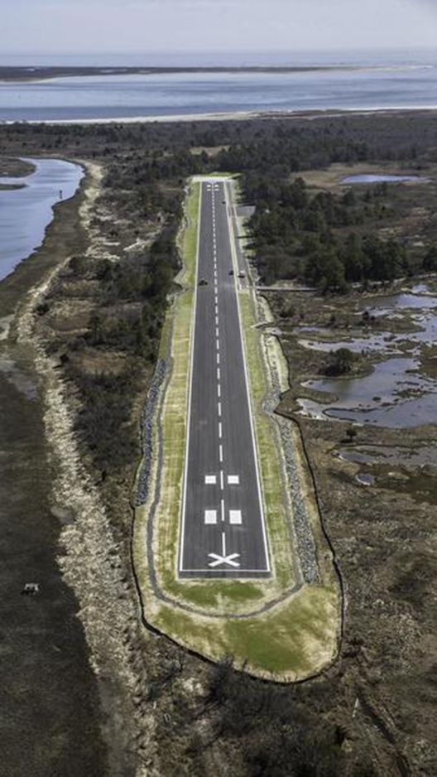
Figure 2: Virginia Space UAS Airfield

Key concepts and principles to be learned during this phase:
- Buoyancy
- Drag and effect of parachutes
- Ideal Gas Law
- Radio signals
- Temperature and humidity relative to altitude
- Data analysis
Phase 2
With analysis of the initial flights in Phase 1B, students will design and test a payload utilizing the ThinSat Engineering Model. Students can select from motherboard and space hardened X-chips, which are manufactured with material to withstand the harsh space environment or develop a customized payload from scratch. This will provide students with an initial understanding of how the payload will ultimately have to be designed for the flight model. Once the payload is tested, the students will integrate the payload with the engineering model and prepare it for a high-altitude balloon fight. This flight will be performed by NSL in Upland, Indiana. NSL will provide four launches with tracking, recovery and live camera video availability for up to 30 engineering models per launch. Students will receive data real-time from each engineering model utilizing the GlobalStar Network.

ThinSat Engineering Model “EM”
The students build an Engineering Model (EM) in Phase 2 of the ThinSat Program. This functional EM of the ThinSat is to be used as a teaching model for the ThinSat Flight Model (FM), the interface between balloon launch and ground station, and for testing the direct connection between the flight processor software and hardware. Mechanically, the ThinSat printed circuit board (PCB) will be Form-Fit-Function to the Generation 1 ThinSat FM unit so all student experiments can be checked with the actual flight processor, electrical interface, ThinSat software, and Space Data Dashboard. No battery, solar arrays, or communication unit will be included. A USB connector is used for ThinSat power and a diagnostic port is included.
A 3-axis accelerometer, a 3-axis magnetometer, and 3-axis gyros (IMU) are included for student testing and learning. Student analog and digital IO are available (just like the FM). Mechanically, the main structure size and mounting screws will be available as on the FM and will be suitable for the balloon vibration and thermal vacuum environment. A full 3-D printed frame is included with flight shape, viewports, and mounting holes. This frame will be made with durable white nylon and selective laser sintering. A polycarbonate clear cover plate will be used on the –Z plate side instead of the solar array PCB. The student payload area will be the same as the FM so flight model student experiments can be tested first in the EM as a simulator for the FM. The EM will be delivered to TSL and tested to make sure they are ready for seamless balloon and FM integration.
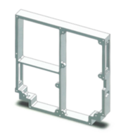
Figure 3: 3-D printed satellite frame

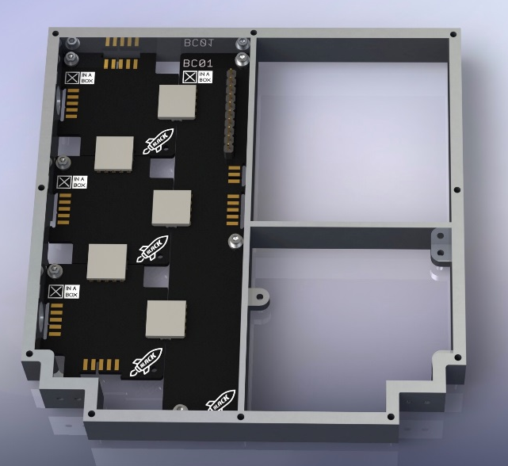

Figure 4: frame with X-Chip motherboard

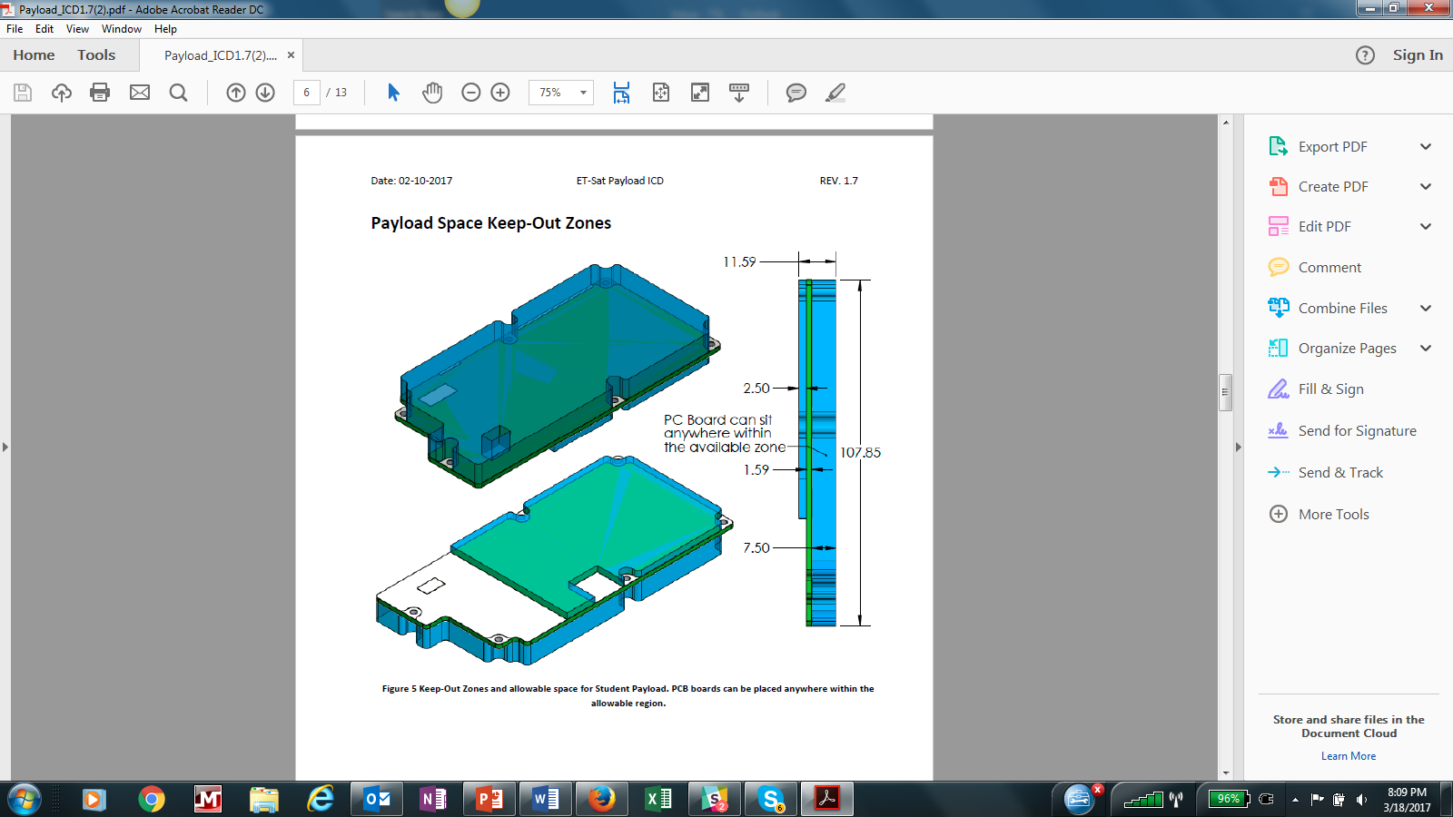

Figure 5: mechanical drawing of the student payload

Phase 3
After completion of the high-altitude balloon flight, student payloads will be sent back to lead institutions. Students will review flight data and determine if the performance of the payload requires modification. Once the payload is selected, students will send their payload to TSL for environmental testing. The payloads are then integrated into the ThinSat FM and loaded into the Containerized Satellite Dispensers (CSDs) developed by Planetary Systems Corporation.
CSDs loaded with the ThinSats are sent to Orbital ATK for integration onto the second stage of the Antares prior to launch. The ThinSats will then be deployed into ELEO after Second Stage/Cygnus separation. Once in contact with the Sun’s light waves the charged batteries will activate and start sending data to the Space Data Dashboard through the Globalstar Network. Students will monitor the data as the ThinSats slowly deorbit and eventually burn up. After completion of the ThinSat mission, students will perform a final data analysis and report of results.

Thinsat as a picosatellite
The ThinSat is a picosatellite that weights approximately 280g and has dimensions of 111 x 114 x 17.4 millimeters. Of these dimensions, approximately fifty percent of the volume will be reserved for student payloads. This area allows space for a customized payload or six X-chip sensors and a motherboard. The ThinSat dimensions are based on the CubeSat form factor. A volume of 1U or a 10-centimeter cube is equal to 7 ThinSats. Therefore, in each 3U CSD, there are 21 ThinSats. Among the 21 ThinSats there will be groups tethered together to form multiple strings, based on multiples of three (3, 6, 9, etc.). The number of strings may differ in separate CSDs; for example, one 3U CSD may have three strings of six and one string of three ThinSats, while another CSD may be comprised of seven strings of three ThinSats. The number of strings determined will be based on relative mission requirements and payload specificity. Each String will have one Mothership and subsequent Daughter-ship(s). See the ThinSat ICD (Dailey, 2017) for more technical information on the ThinSat payload and operation.
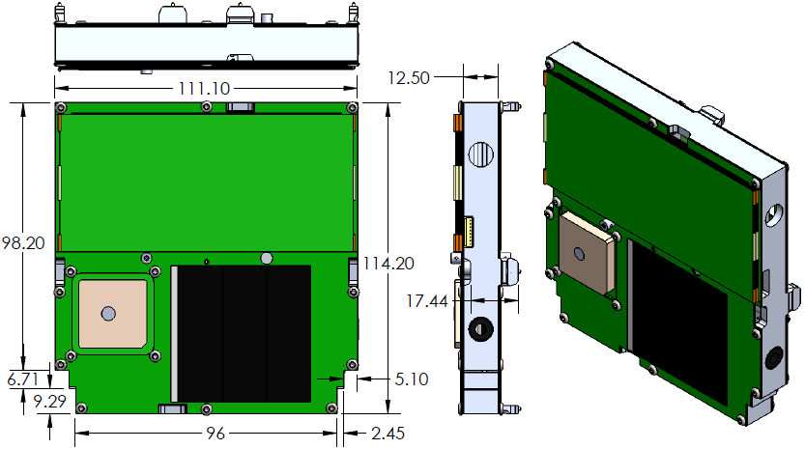
Figure 6: ThinSat Dimensions in Millimeters
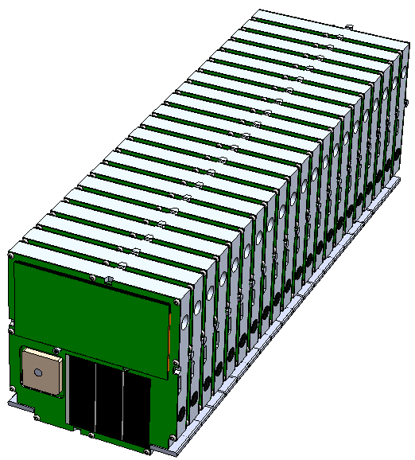
Figure 7: ThinSat Configuration for Deployment

Mothership Hardware
The mothership ThinSat of a string will contain the following hardware:
- Student Payload
  - Customized payload
  - Space Hardened X-Chips
  - Sensors provided manufactured by NSL
- Globalstar Radio
- Flight Processor
- Piksi GPS
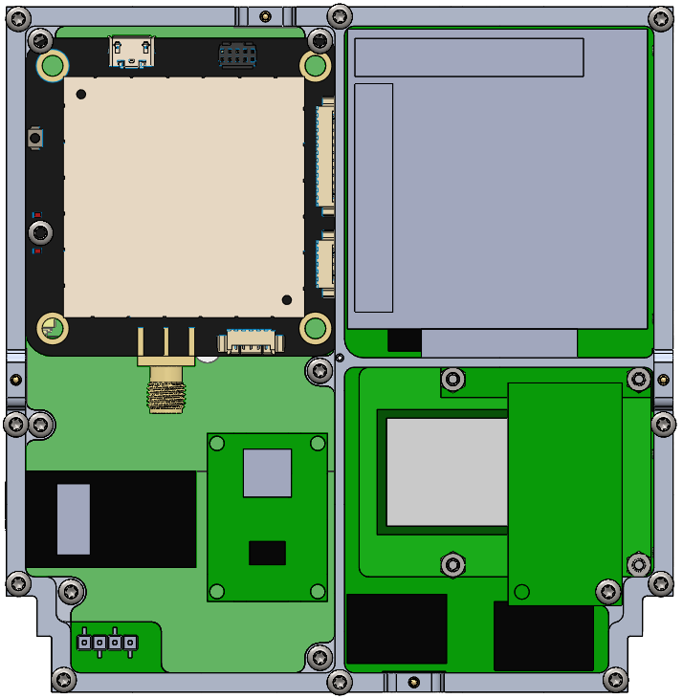
- Foldout Camera

Figure 8: Mothership Space Utilization

Daughtership Hardware
The first daughter-ship will supplement battery power to the mothership, which demands more battery power. The daughter-ships will contain the following:
- Student Payload
  - Customized payload
  - Space Hardened X-Chips
  - Sensors provided, manufactured by NSL
- Globalstar Radio
- Energetic Particle Detector
- Plasma Probe Board
- Flight Processor
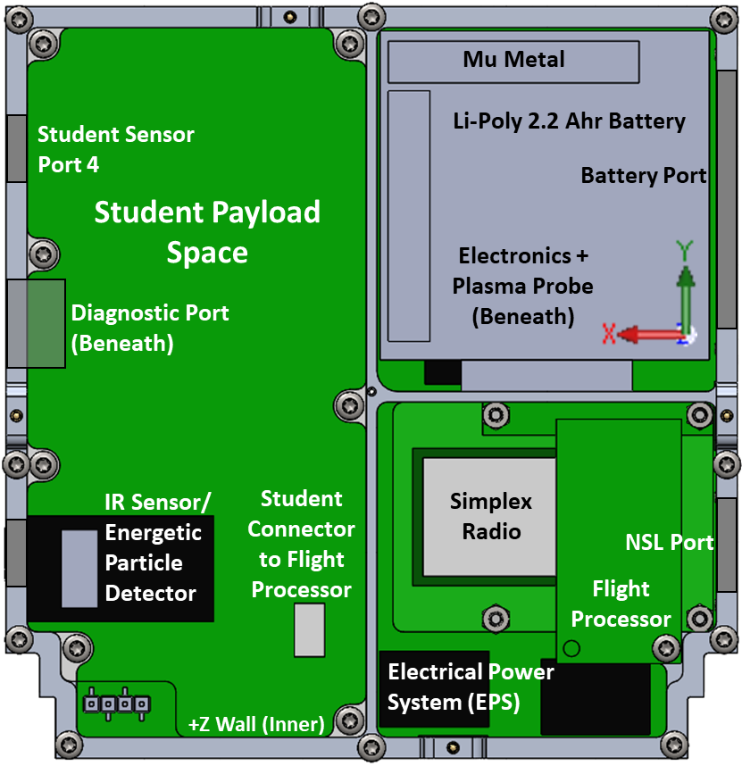

Figure 9: DaughterShip Space Utilization

ThinSat Grouping Types and Tethering Options
The ThinSats will be grouped according to mission requirements and payload specificity. The tethers used to group the ThinSats will be either nitinol wire or nitinol ribbon with solar arrays attached.
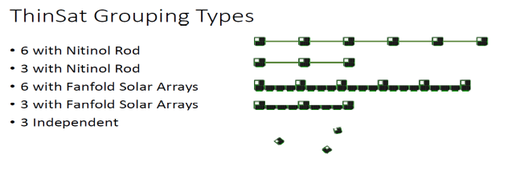
Figure 10: ThinSat Grouping Types

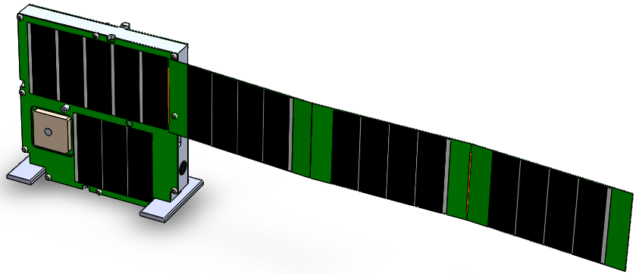
Figure 11: ThinSat Fanfold Solar Array
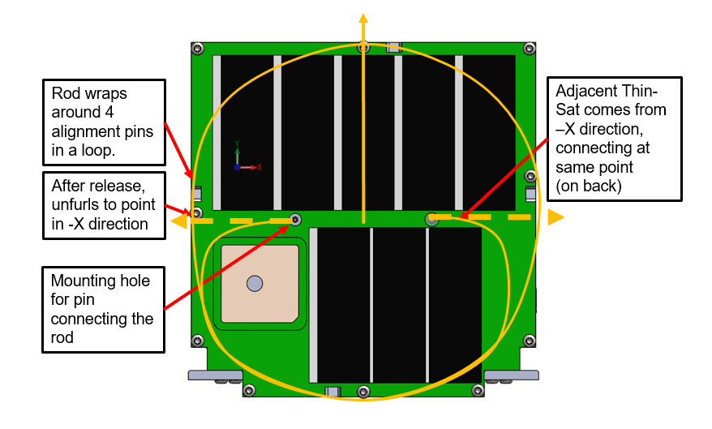
Figure 12:Nitinol Wire Configuration

SPace Data Dashboard
The ThinSat Program will have a user-friendly Space Data Dashboard that will act as a focal point for data analysis and collaboration amongst participating schools. This interface will be accessible through the Virginia Space website and will allow institutions to create plots for sensors being used during the program. The plots will be populated during sensor testing, balloon flights, and during the flight in orbit. Data will be plotted real-time and stored for accessibility at any time. Student data from each mission will be stored and open for the entire ThinSat community, allowing students to view, compare, and analyze data sets from any institutions’ flight.
Aside from viewing and storing data, the Space Data Dashboard will act as a “one place” reference for all the information on the ThinSat Program. There will be a wiki sub-page for information regarding the program phase instructions for teachers and students, past analysis reports from participating schools, and collaboration board or blog where questions or results can be posted.
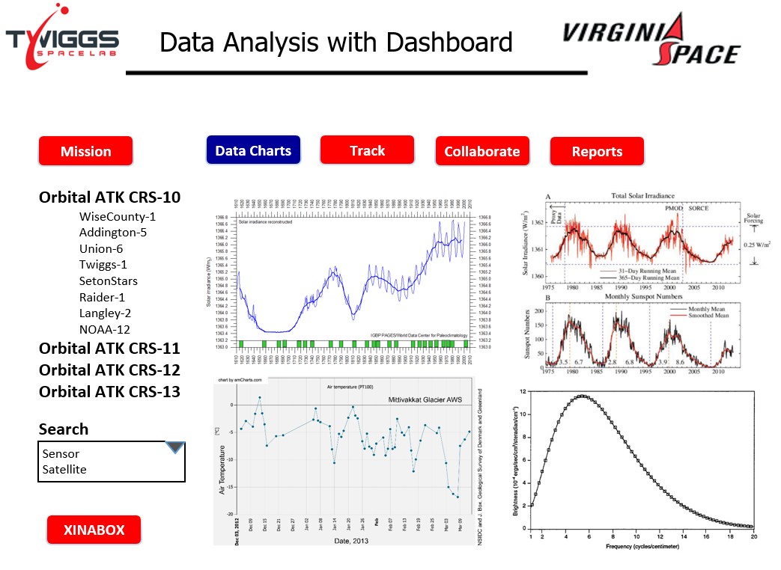
Figure 13: Space Data Dashboard Interface

Education and Curriculum
The curriculum developed for the ThinSat Program is intended for students in middle and high school. The same guidelines and principles are followed for each of the three phases, but a broad range of STEM subjects and sophistication levels can be studied depending on the complexity of the student payload. For the standard X-chip sensors, a user-friendly model is prepared so younger students may participate in the program. Students in 11th grade through college may want to develop a separate payload, therefore a structured curriculum need not be followed. Instead, the students can prepare a midterm and final report on the reason they chose the specified payload, the data accumulated and the purpose of the findings.
The ThinSat Program will use a club-style approach, where the number of meetings will be determined by each school. A recommended curriculum was developed using the Next Generation Science Standards (NGSS) and State Developed Standards to incorporate required topics into the ThinSat Program. An assessment test will be provided at the start and end of the program to track student progress and ensure student learning.

The Science Standards Topics to be Covered by the ThinSat Program Curriculum

Earth Space Science
- Weather and Climate
Students will collect and analyze data from multiple locations, across the nation and globe. This allows students a unique opportunity to examine the different weather systems and how to explain atmospheric data relative to location and time.
- Space Systems
In phase 3, students will explore the effects of microgravity, orbital life, orbit inclination, and solar flux on the ThinSats. This will allow for an understanding of why the ThinSat deorbits at different time intervals, but always close to a week.
- Earth Systems
To incorporate earth systems, students will investigate the water cycle with the temperature, humidity and pressure using x-chips. This data will be analyzed relative to altitude and atmospheric density.

Life Science
- Matter and Energy in Organisms and Ecosystems
Through data analysis, students will be able to gain an understanding of Earths biotic and abiotic factors. They will also be able to understand and explain human impacts on various ecosystems.

Engineering, Technology, and Application of Science
- Engineering Design
The ThinSat Program as a whole, represents the iterative engineering process. Before the final ThinSat payload is manufactured, students use Phase 1 to understand how the sensors work through various tests and a low altitude balloon flight. Next, they use an engineering model to design and test a payload using the High-Altitude Balloon Flights. If everything is nominal and no modification is required, the students have completed building and testing a successful payload that is ready for space flight testing and ultimately orbiting Earth.
Table 1: Curriculum Schedule Breakdown
Phase: | Duration: | # of Sessions: | Classroom/Club Hours:
1 | 15 weeks | 15-30 | 15-45
2 | 14 weeks | 14-28 | 14-42
3 | 8 weeks | 08-16 | 08-24

Curriculum structure within ThinSat Program phases to incorporate Science Standards
To incorporate the standards above, each phase will be broken down into sections, which last anywhere from 2-5 weeks. It is anticipated that schools in the program will learn at different paces; thus, flexibility is provided as long as the phase is completed on time and all section requirements have been satisfied

Phase 1: Sensor Development and Low Altitude Balloon Flights
- Essential Questions: Use NGSS and State Developed Standards to generate interest in topics
- Research Window: Determine methods to answer essential questions with hardware provided
- Design and Manufacture: Build FlatSat Payloads to obtain data to help explain essential questions
- Testing Protocol: Test FlatSats to ensure usability
- Final Product: Use final FlatSat payload on low altitude balloon flights

Phase 2: High Altitude Balloon Flights and Data Analysis
- Essential Questions: Develop questions in topics related to the high-altitude balloon Flight
- Research Window: Determine methods needed to answer essential questions
- Design and Manufacture: Build payload with dimensions of ThinSat Flight Payload
- Testing Protocol: Test payload using ThinSat Engineering Model
- Final Product: Use Payload and Engineering Model on high-altitude balloon flight

Phase 3: Flight Testing, Integration, Launch Preparations, and Final Reports
- Essential Questions: Develop questions in topics related to launch and flight of the ThinSats in orbit.
- Testing Protocol: If necessary, make modifications to payload from Phase 2. Test payloads for flight in orbit.
- Data Analysis and Final Reports: Analyze data from the ThinSats in Orbit and develop a final report.

Timeline
For any selected launch, there will be a group of lead institutions, universities or professional institutions, who enlist local schools. It is the responsibility of lead institutions to assist and guide schools they involve in the program, through the 14-month three-phase program. Designating the Antares launch date as ‘L’, the timeline of events proceeds as follows:

L-14 Months: Delivery of XinaBox Kits

L-14 Months: Start of Phase 1
Students will use the Xinabox kits delivered at L-14 to program and design FlatSats. Low-Altitude balloon and UAV flights to be conducted, data analyzed, and payloads modified.

L-10 Months: Start of Phase 2
Modified FlatSat payloads are designed to fit in the student payload space of the ThinSat EM. The model will be used to test payload and verify data transmission. The payloads are then integrated and secured within the EM in preparation for the high-altitude balloon flight. Students then send the EM with the payload integrated to NSL for the high-altitude balloon flight.

L-06 Months: Start of Phase 3
After completion of the high-altitude balloon flight, the engineering models with student payloads are sent back to the lead institutions, who analyze data to make changes to the payload if necessary. Final modifications are made to the student payloads and sent to TSL for orbital flight testing.

L-04 Months: TSL Testing of ThinSat Flight Models
TSL will conduct the environmental testing of the spacecraft at the Morehead State University’s Spacecraft Environmental Testing Laboratory (SETL), located within the Space Science Center, which provides for testing and qualification services for spacecraft up to 100-kg. The SETL is capable of supporting Hardware in the Loop (HWIL) testing to NASA GEVS level and greater. The SETL has a rich heritage of testing and qualifying in-house built satellites and is available as a commercial service for both public and private sectors. The space environmental testing will include:
- EMI/EMC Testing
Complete EMI/EMC Testing to MIL-STD-461C: Electromagnetic Emission and Susceptible Requirements for the Control of Electromagnetic Interference.
- Vibration Testing
Vibration testing verifies satellite survivability post launch and can identify mechanical and structural faults and stresses. The SETL’s vibration slip table allows for 3-axes of testing at or above NASA GEVS levels and can be customized per mission ICD.
- Thermal Vacuum Testing
Thermal vacuum (T-Vac) testing verifies satellite performance in a simulated space environment with temperature extremes beyond that which the satellite is expected to experience on orbit. The SETL’s T-Vac system has a capacity of 0.29 m³ (10 ft³) and a temperature range of -100°C to +220°C at 1x10-8 torr. Pass throughs allow for functional testing under vacuum.

L-01 Month: CSDs with ThinSats are sent to Orbital ATK for integration with Antares Second Stage

L-00: Launch of the Antares

L+10 minutes: Second Stage-Cygnus Separation

L+12 minutes: Deployment of ThinSats

L+05 days: Estimated ThinSat orbit lifespan
The orbital lifespan of the ThinSats will vary depending on atmospheric parameters.

L+1-3 Months: Final Report Due

Conclusion
The ThinSat Program was specifically developed to engage students of all ages in science, technology, engineering, and mathematics. In order to follow academic schedule guidelines and reach a broad profile of students, this program provides a flexible curriculum. Teachers will not be constrained by single lesson plans, but rather curriculum guides that introduce general concepts and how they can be studied. The ThinSat Program provides an approachable and recurring opportunity each academic year for students and teachers to collaboratively participate in hands-on space science and engineering, opportunities which were previously reserved for research universities with long time horizons. This exposure will hopefully encourage students to enter into STEM fields and ultimately help foster the next generation of scientists and engineers in the aerospace arena. Their participation in the ThinSat Program could provide both the spark of engagement and practical application of the scientific method to help prepare the next generation. ThinSats will allow students of all grades to get their fingerprints into space, providing a positive impact on the vitality of the industry and the future of space exploration.

Acknowledgments
We would like to thank the Virginia Space Consortium for the support and funding of this project.

References
- Jayaram, S., Swartwout, M.A. (2010). A review of the role of student-built spacecraft in workforce training and innovation: Ten years of significant change. AIAA Space 2010 Conference & Exposition. doi: 10.2514/6.2010-8735
- Toorian, A., Diaz, K., Lee, S. (2008). The CubeSat approach to space access. Aerospace Conference, 2008 IEEE, doi: 10.1109/AERO.2008.4526293
- Zillman, C. (2013, November 12). The average age of aerospace engineers in the U.S. is 47, and many of these jobs can’t be filled by foreign workers. Fortune, Retrieved from http://fortune.com/2013/11/12/americas-defense-industry-is-going-gray/
- Voss, H., Dailey, J., Orvis, M., White, A., Brandle, S. (2016). "Globalstar link: From reentry altitude and beyond." Small Satellite Conference. Logan, UT. http://digitalcommons.usu.edu/smallsat/2016/S7Comm/1/.
- Dailey, J., Orvis, M., Voss, H. (2017). "ET-Sat Student Payload Interface Control Document." www.NearSpaceLaunch.com.

